## TEAMS HOT SHOTS

**Project for manufacturing practice**

**July 2021**

Table of Contents

1. Topic

2. Authors

3. Our goal

4. Stages of development

5. Difficulties

6. Block diagram

7. Used technologies

1. Topic

* The topic of our project was to create a app will manage a list of applications made by parents to apply for students aged 12 to 16 to be placed in a dormitory at a school.
* The system will require parental registration. Each parent will be presented with a username, password, first name, last name, address, name and surname of the student, age of the student.
* A functionality will be created that will search by certain criteria: address, age of the student. At given points for each of the cities from which the students come, it will be possible to give points that form a score for applying to the dormitory.

1. Authors

* Ivo Dimov – [IMDimov18@codingburgas.bg](mailto:IMDimov18@codingburgas.bg)
* Todor Bozhinov – [TDBozhinov18@codingburgas.bg](mailto:TDBozhinov18@codingburgas.bg)

1. Our Goal

* Our goal is from a creating an application for managing a dormitory application to a school.​
* It will allow applications to be sorted and searched for by parents according to certain criteria.

1. Stages of development

* Discuss the project​
* Implement menus​
* Implement main functions​
* Separate the code into files​
* Make documentations​

1. Difficulties

• During the implementation we had almost no difficulties, we distributed our roles without any problems, everyone was responsible for certain parts of the project. This was the main reason for the success of the project

1. 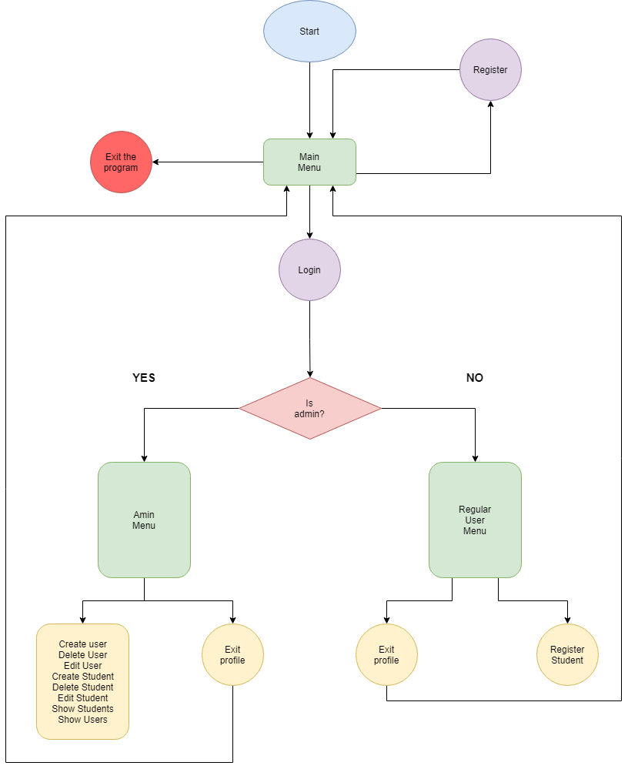Block diagram
2. Used technologies

* Visual studio
* We used C++ as our programing language and Visual Studio as our programming environment.
* Excel
* Excel was our tool for making the QA test cases.
* Word
* On Word we wrote our documentations.
* PowerPoint
* We used PowerPoint for the presentation.
* GitHub
* We managed our project on GitHub.
* Teams
* The communication we did on Teams.